The complete Remote Access software suite

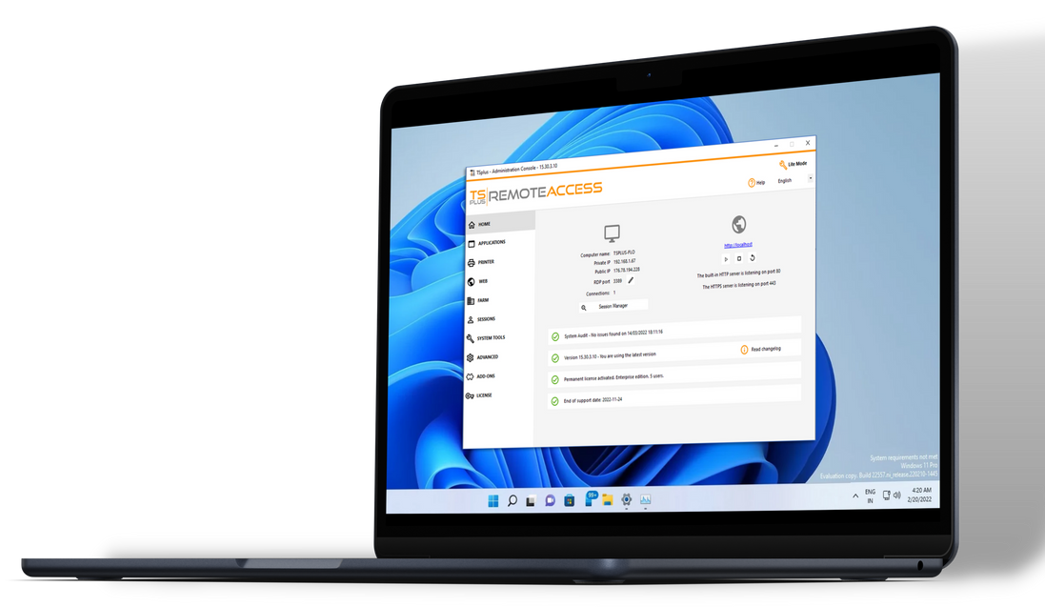

5 Remote Desktop and Application Delivery Solutions for IT Professionals. Our family of software covers a wide range of remote access needs with a core value: simplicity.
TRUSTED BY OVER 500,000 COMPANIES

2023
EDITION

AFFORDABLE TECHNOLOGIES
BENEFITS FOR YOUR BUSINESS

FAST TO SETUP AND DEPLOY

USER-FRIENDLY INTERFACE
PERPETUAL LICENSES
sales@tsplus.net
France, USA, Czech Republic, India
www.tsplus.net

SECURE CONNECTIONS

SCALABLE SOLUTIONS

Remote Access

REMOTE ACCESS

Remote Desktop and Application Delivery

Secure, Scalable and Cost-Effective

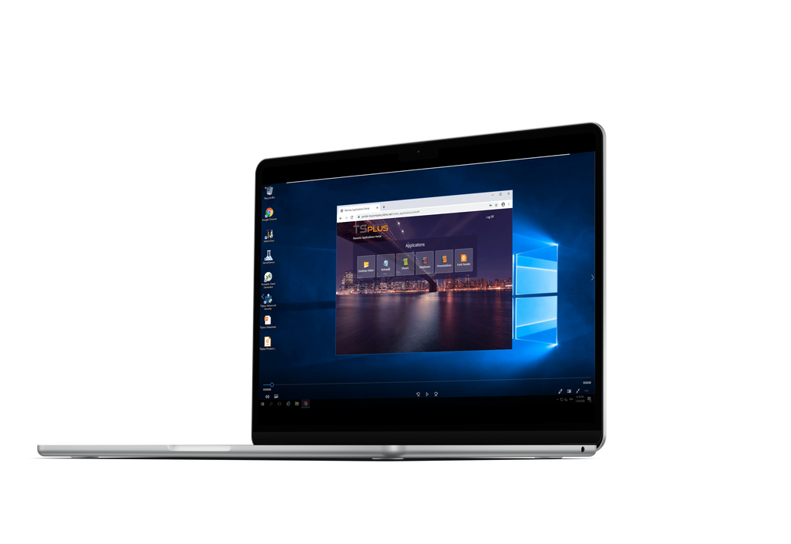
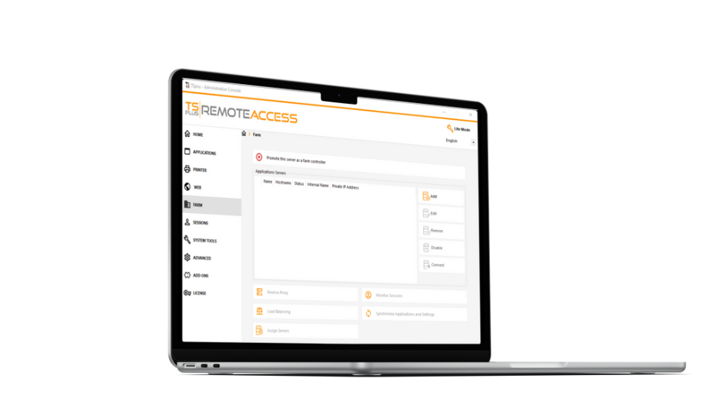
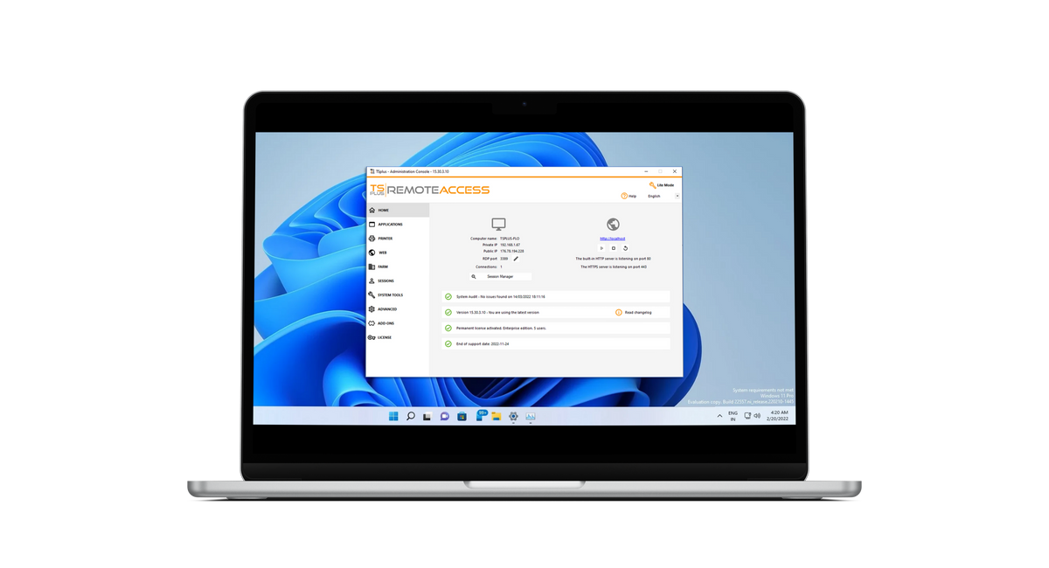
Secure Remote
Access
Web App Portal
Server Farm Management
Web-Enable Apps
Custom Solution
Enterprise Features

from $25/user
(UNLIMITED USERS - Desktop edition)
Buy Now
www.tsplus.net/remote-access/
Publish Windows apps on a cloud or corporate server and give direct access to remote users on any device via RDP or HTML5 clients.
Various connection modes and settings available to build a secure remote infrastructure: 2FA, SSL encryption, remote printing...
Advanced Settings adapted to the needs of large organizations: server farm, load-balancing, reverse proxy, gateway portal...

Advanced Security
ADVANCED SECURITY

Remote Desktop Security

Sessions and Servers Protection

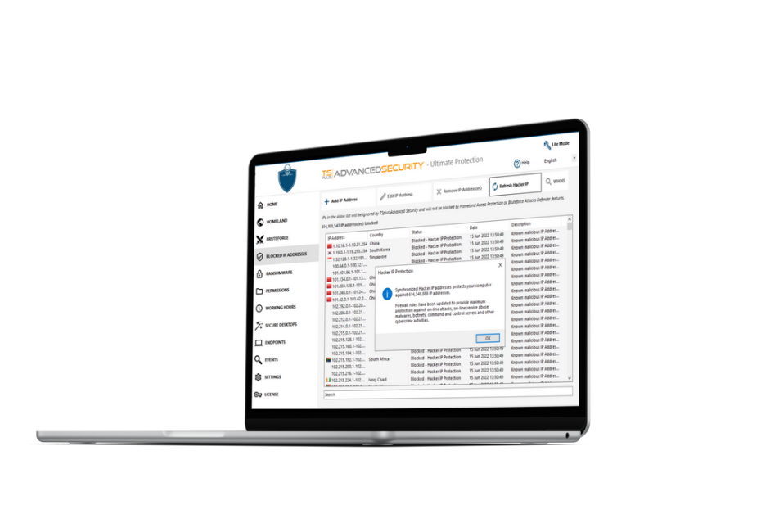
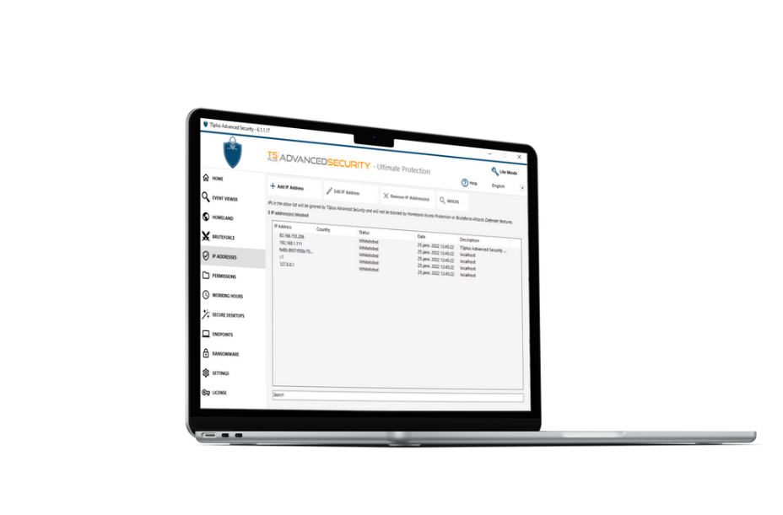
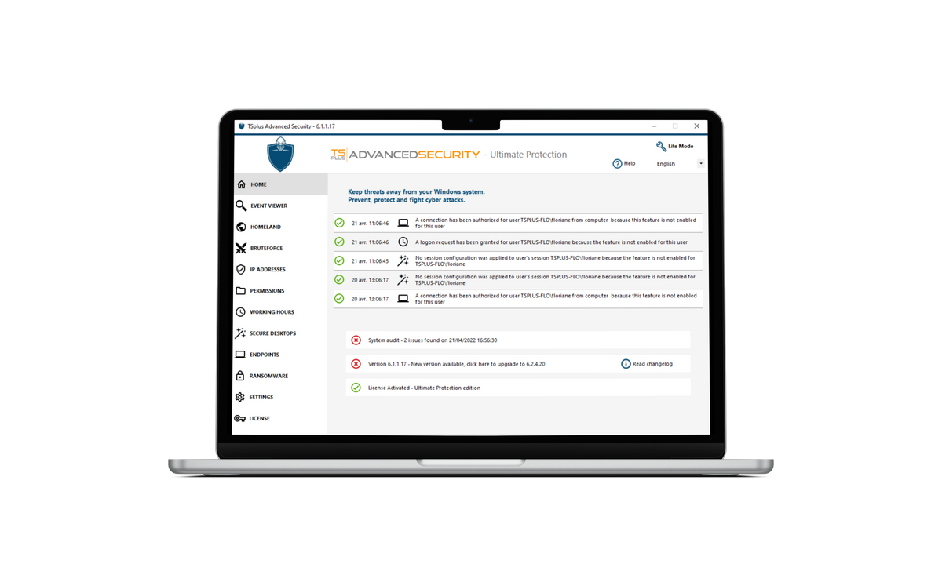
Access Restriction
Attacks Defender
User Rights Policies
Efficient from Day 1
Up to 7 Features
Easy Management

from $50/SERVER
(4 features - essentials edition)

Buy Now
www.tsplus.net/advanced-security/

Automatically blocks +600 million known hacker IP addresses. Monitors all risks and actions in the Event logs.

Limits connections by country, time of the day and devices. Blocks brute- force and ransomware attacks.

Easy to setup on a Windows server or desktop with a LITE mode available. Central IP addresses management.

Remote Support

REMOTE SUPPORT

Windows Session Sharing

Cost-effective and Secure

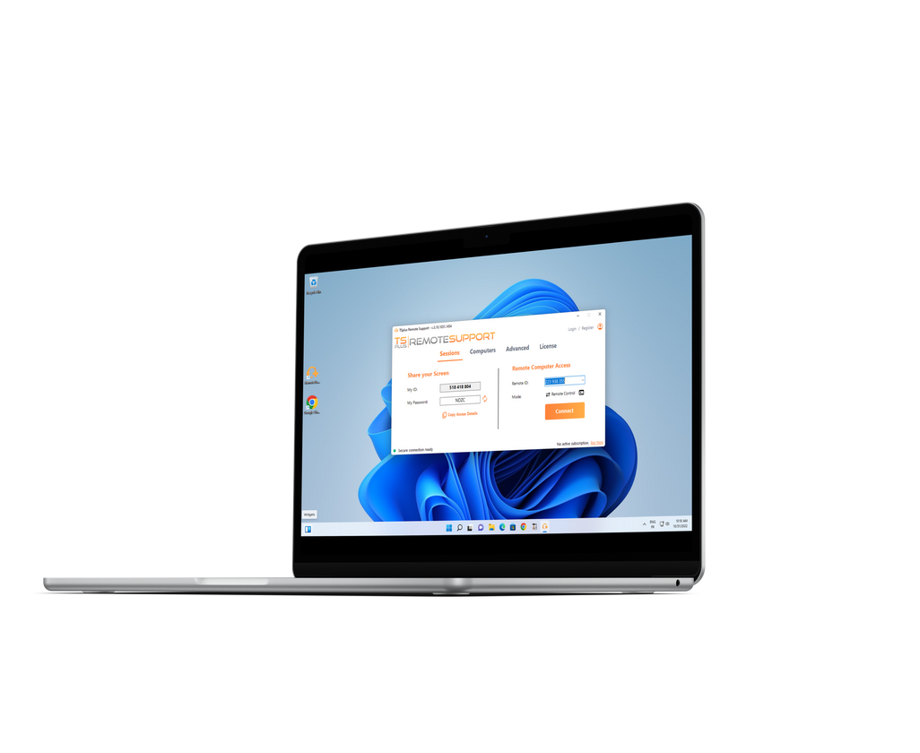
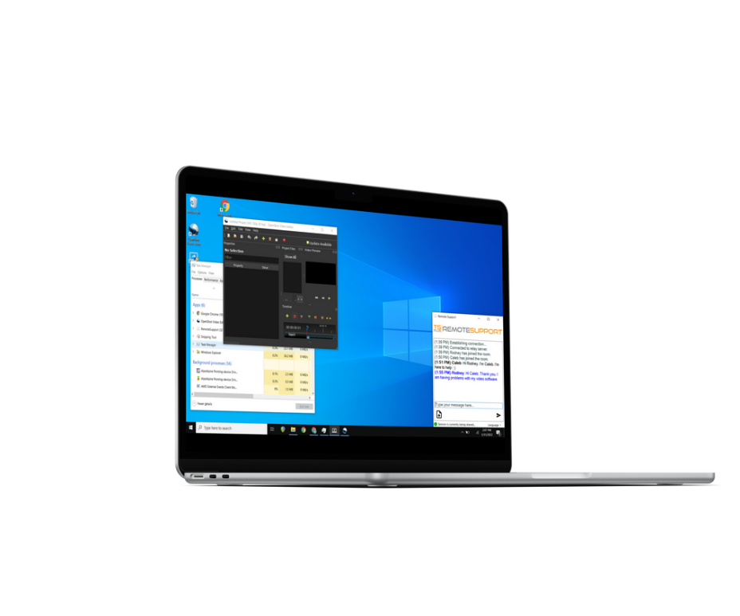
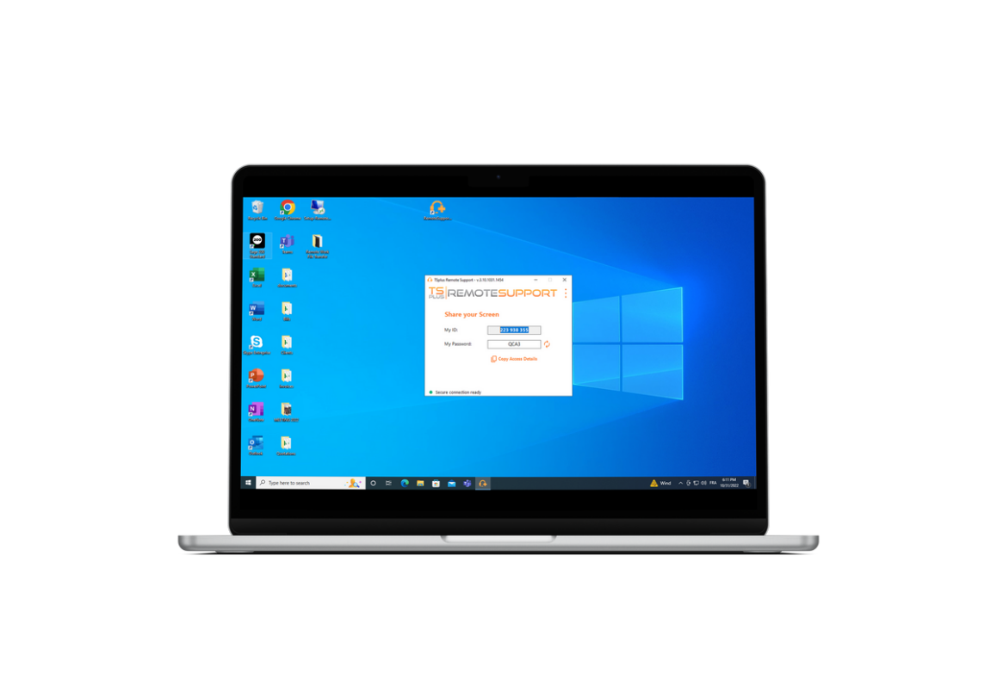
Remote PC Control
Screen Sharing
Unattended Access
Zero Installation
Quick Connection
Collaboration Tools
Small program to download and run on both sides. No setup needed.
Chat box, file transfer, multi- agents connections, send command line, and more.

Lite Connection Client. Session sharing in a click with ID and Password.
FROM $8/MONTH
(1 USER/ 1 concurrent connection - starter edition)
Buy Now
www.tsplus.net/remote-support/

Server
Monitoring

SERVER MONITORING

Server and Website Monitoring & Reporting

Comprehensive, Easy-to-Use, and Accurate

Remote Access Monitoring
Monitors all servers, websites, apps, and users of a remote work infrastructure from one place.
Network Administration

User-Friendly Tool
Add or remove servers in minutes, with customization options for reports and alerts (email & pop-up).

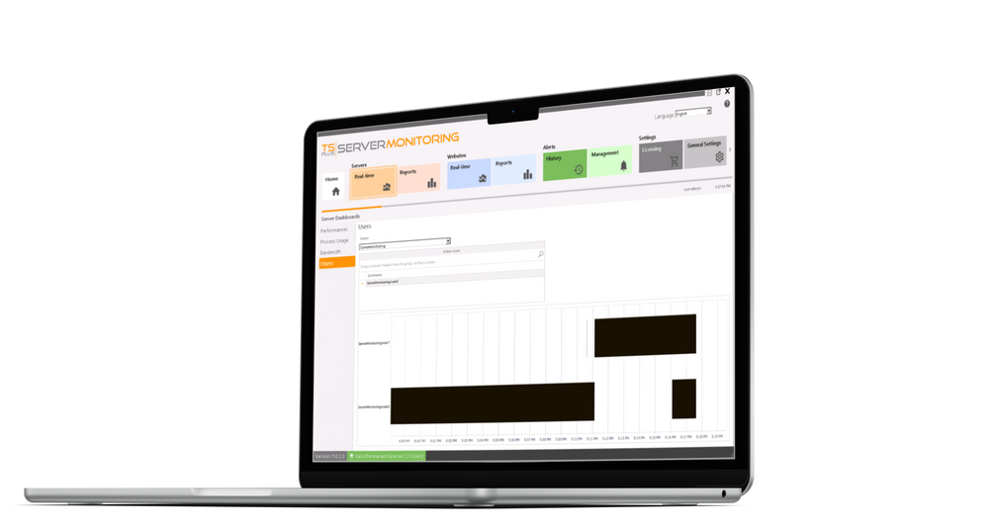
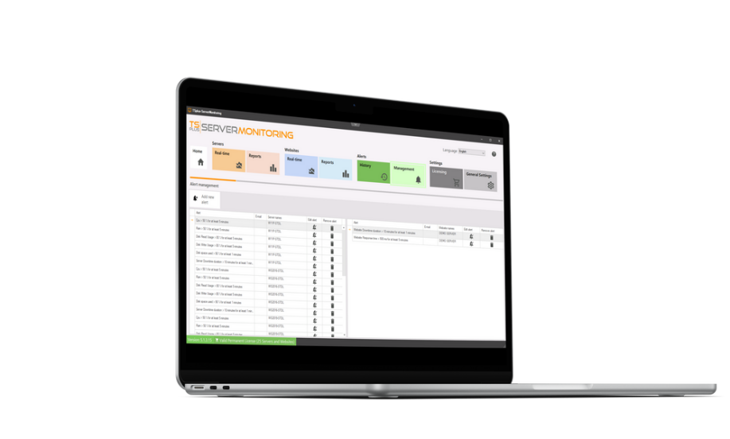
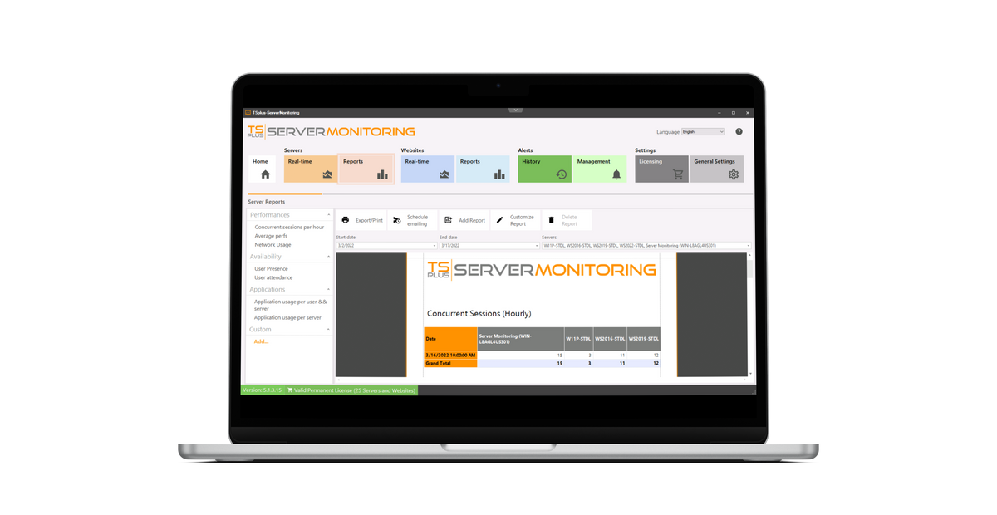
Smart and easy-to-read reports with historical and real-time data about performance and usage.
Real-Time Monitoring
Custom Reporting
Automatic Alert System

from $90 FOR 1 SERVER
(and 1 website - essentials edition)
Buy Now
www.tsplus.net/server-monitoring/

Remote Work
REMOTE WORK

PC to PC Remote Gateway

Secure, Easy to Deploy and Affordable

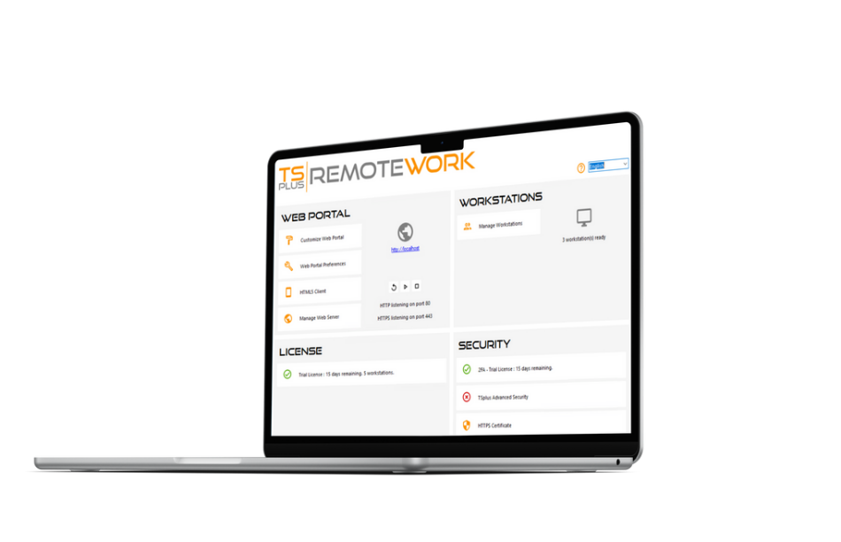
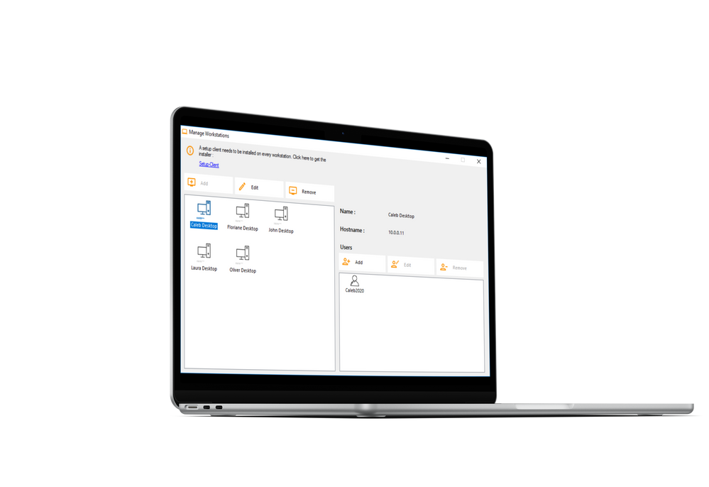
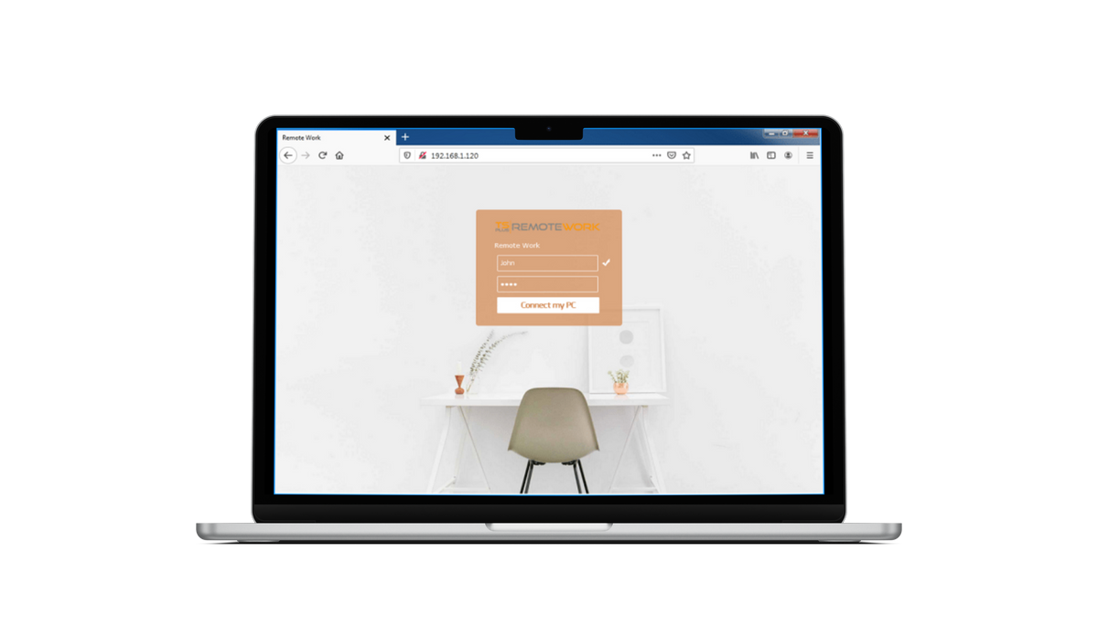
Remote PC Access
Web Portal
On Premise- Installation
Self-Hosted Gateway
Multi-device Access
User-Friendly Solution

from $25/WORKSTATION
Buy Now
www.tsplus.net/remote-work/
Customizable and secure single sign-on web portal to allow remote work from any device.
The Remote Work connection broker is a Remote desktop gateway AND a web server!
Direct access to office PC for zero work disruption: session capture, remote printing, multiple users...

